Call Reports

Raw data location:
How to download:

Part 1: 2001—
- https://cdr.ffiec.gov/public/pws/downloadbulkdata.aspx

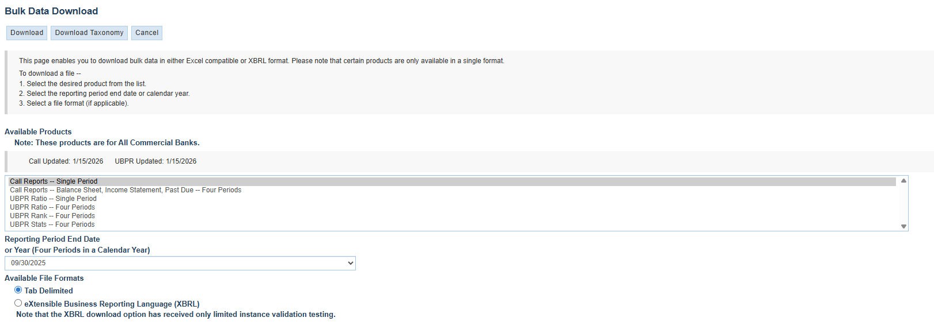
- This downloads a single period .zip file
- Unzip the file on your local computer (it will look like “FFIEC CDR Call Bulk All Schedules 09302025” and contain a lot of individual files)
- Upload this folder to the yens directory TBD/raw/MMDDYYYY/<all the files>
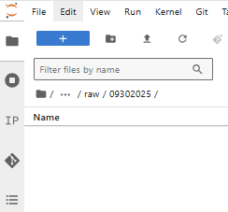
- Select all and upload
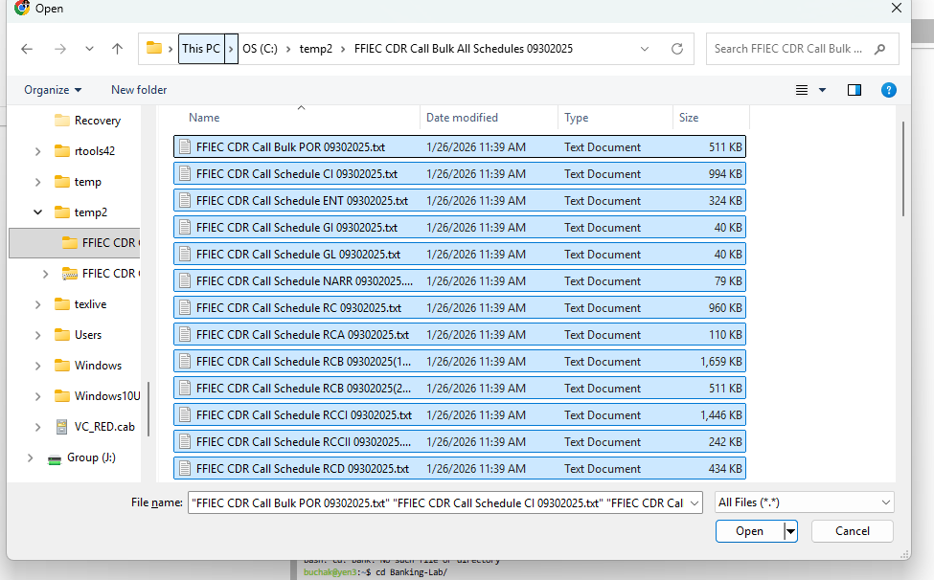
- Repeat for all available quarters
- Save documentation in TBD/raw/documentation/<forms>
- Or raw/documentation/<instructions>
  - https://www.ffiec.gov/resources/reporting-forms
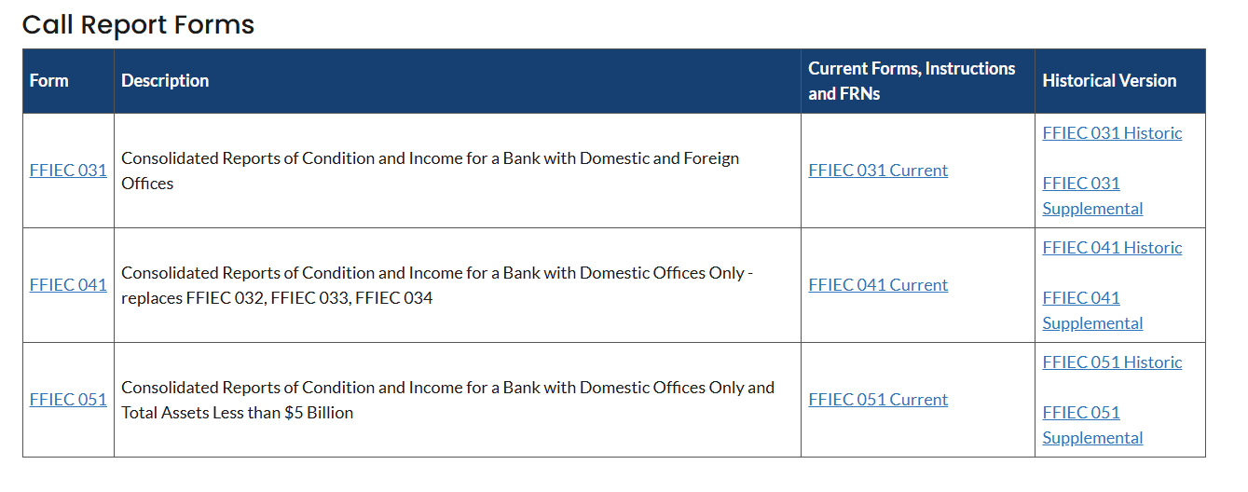
  - E.g.,
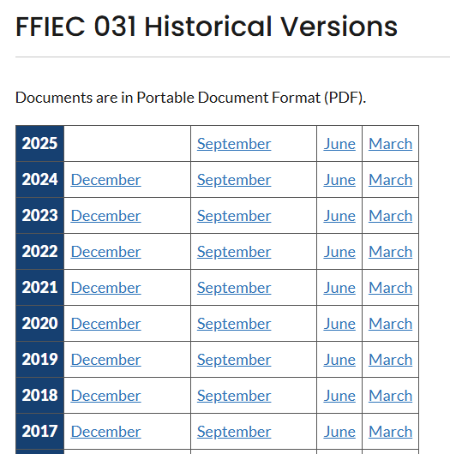

  - Download all of these
  - Call report instructions
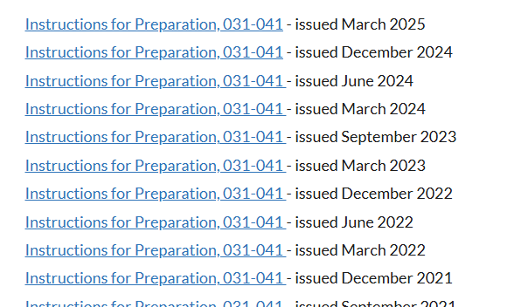

Part 2---Pre 2001
- https://www.chicagofed.org/banking/financial-institution-reports/commercial-bank-data
- https://www.chicagofed.org/banking/financial-institution-reports/commercial-bank-data-complete-1976-2000
- 4 for each year
- They all go into their own quarterly folders (same naming convention)

Documentation

